TaskTick is an individual project completed entirely by myself, Coral Jin. All design, development, testing, and documentation were completed independently. I would also like to apologize for occasionally forgetting to upload my updates to GitHub. This was an oversight on my part, and I recognize the importance of maintaining an up-to-date repository. I will ensure that future updates are uploaded in a timely manner.
GitHub Link: https://github.com/coraljin22/5007.git

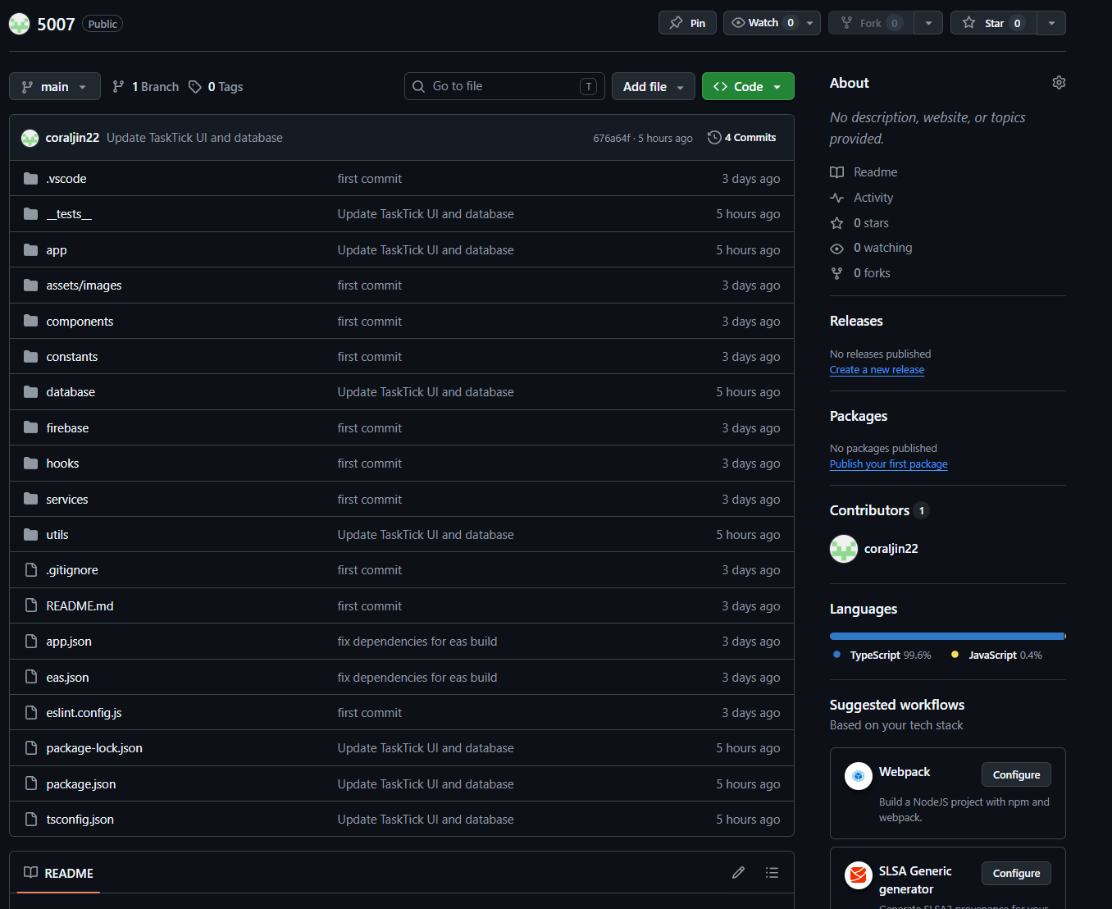
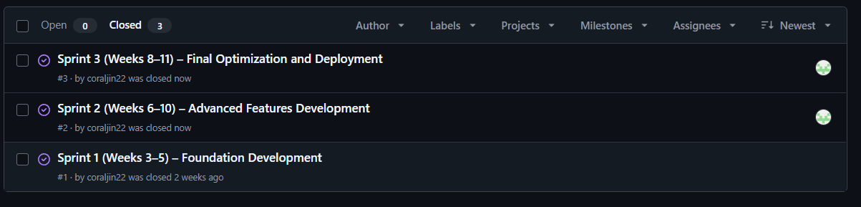
Github screenshot
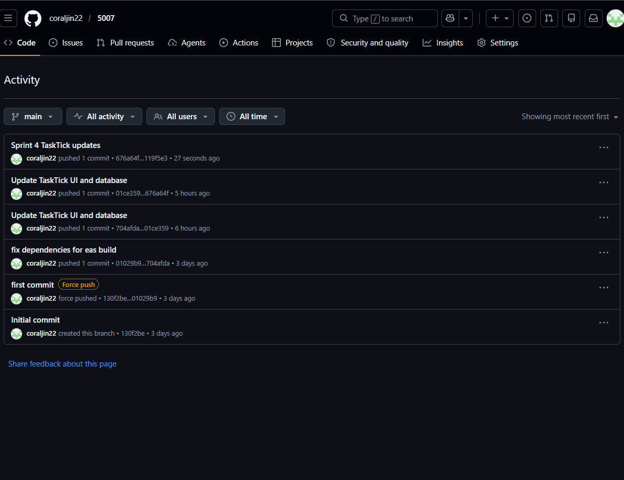
Github Activity

Jira Screenshot
